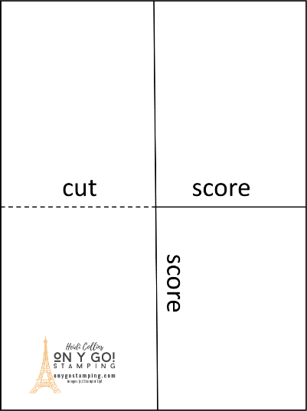
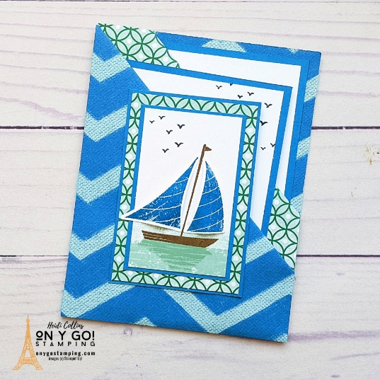
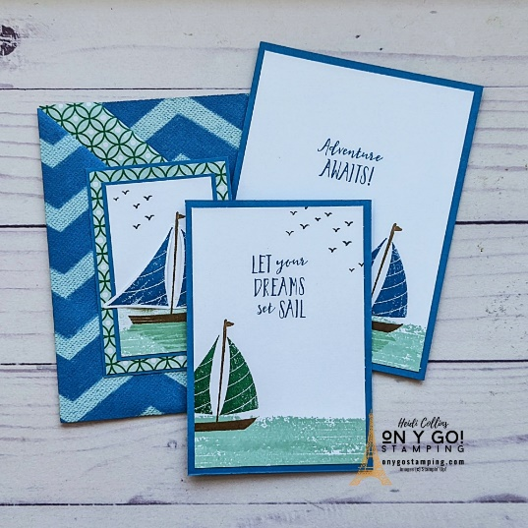
Video demonstration: https://youtu.be/AHjlqACDZJM
All images © 1990-2022 Stampin’ Up!
Basic Dimensions & Supplies:

Patterned Paper: 8 ½” x 11”
Patterned Paper (front): 2 3/8” x 3 3/8”
Cardstock (layer 1): 5 ¼” x 4”
Cardstock (layer 2): 4 ¾” x 3 ¼”
Cardstock (layer 3): 2 ½” x 3 ½”
Cardstock (layer 4): 2” x 3”
white or vanilla cardstock (layer 1): 5” x 3 ¾”
White or Vanilla cardstock (layer 2): 4 ½” x 3”
White or Vanilla cardstock (layer 3): 1 7/8” x 2 7/8”
Paper trimmer or Score Board

Tips:
- Score the patterned paper in half on each side (5 ½” on the 11” side and 4 ¼” on the 8 ½” side).
- Lay the patterned paper in front of you with the pattern you want to see more of facing up.
- Cut the score line on the left side to the center.
- Fold the lower right corner up so that the bottom edge matches the score line in the center.
- Fold the upper left corner down so that the top edge is about 1” from the center score line.
- Fold the upper left quadrant to the right on the center score line.
- Fold the bottom left quadrant under on the center score line.
- Fold the bottom right corner over to match the bottom corner you folded previously. Adhere.
- Open the folded bottom corners and put adhesive along the left edge of the bottom right quadrant. Fold the corners to adhere them.
- Put adhesive along the left edge of the bottom quadrant again. Fold up on the score line over the top quadrant.
Heidi Collins, Independent Stampin’ Up! Demonstrator
www.onygostamping.com
This tutorial is private and may not be sold or distributed.
Please do not share these copyrighted tutorials with others. Thank you!

